Task on Rds

- Create MariaDB DB on EC2.
Created a ec2 instance
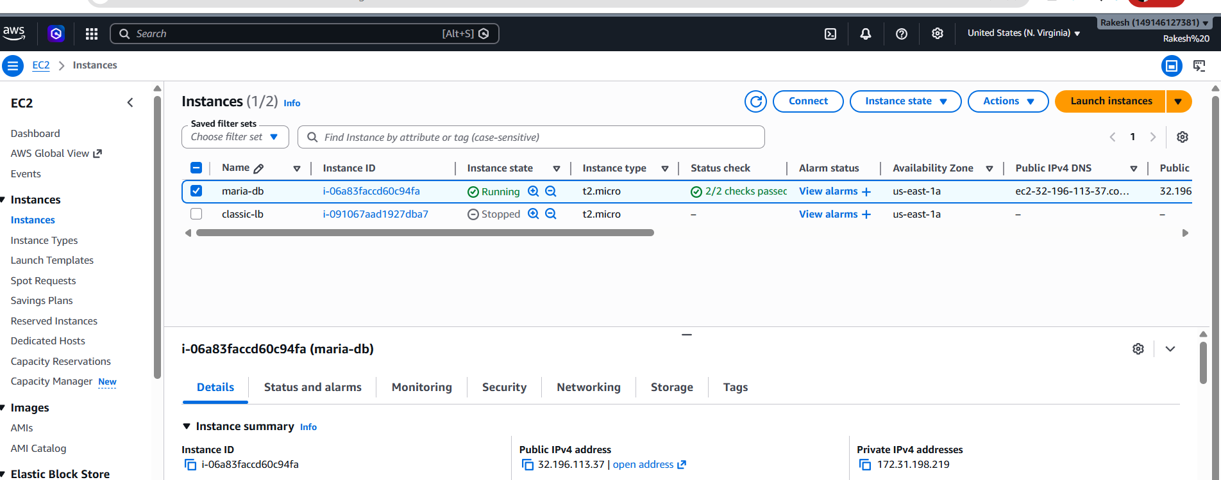

Installed mariadb
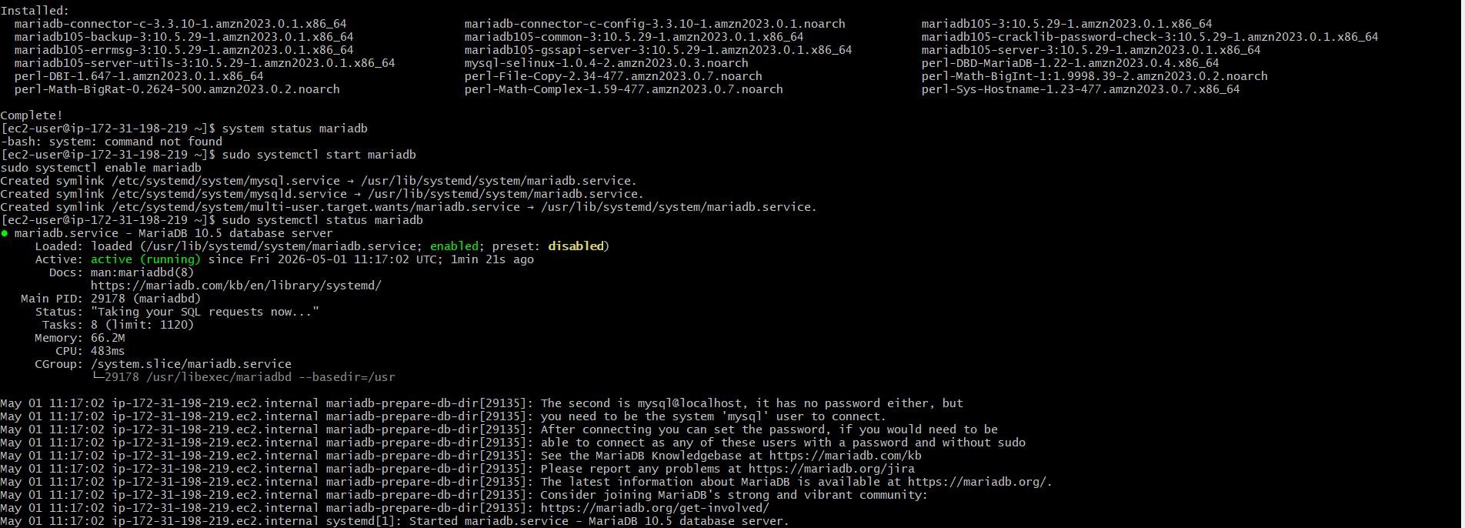

- Start and Enable MariaDB
- Secure MariaDB Installation
- Login to MariaDB
- Create Database

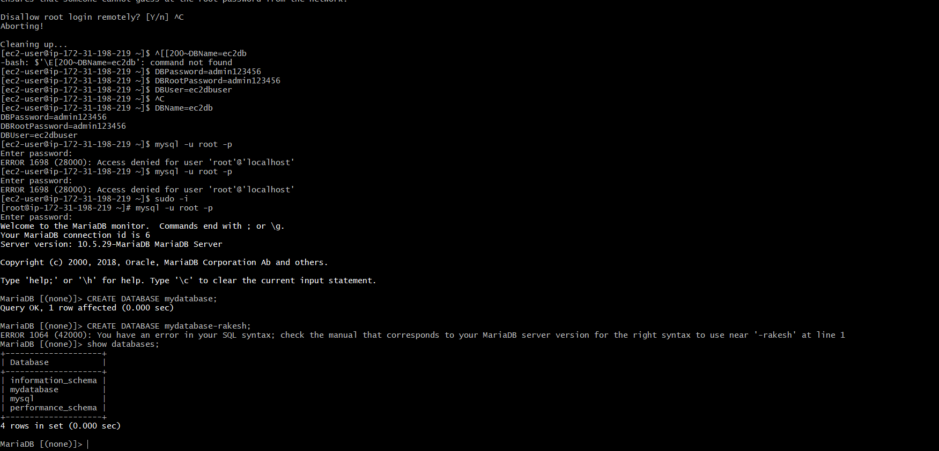
- Create User and Grant Access

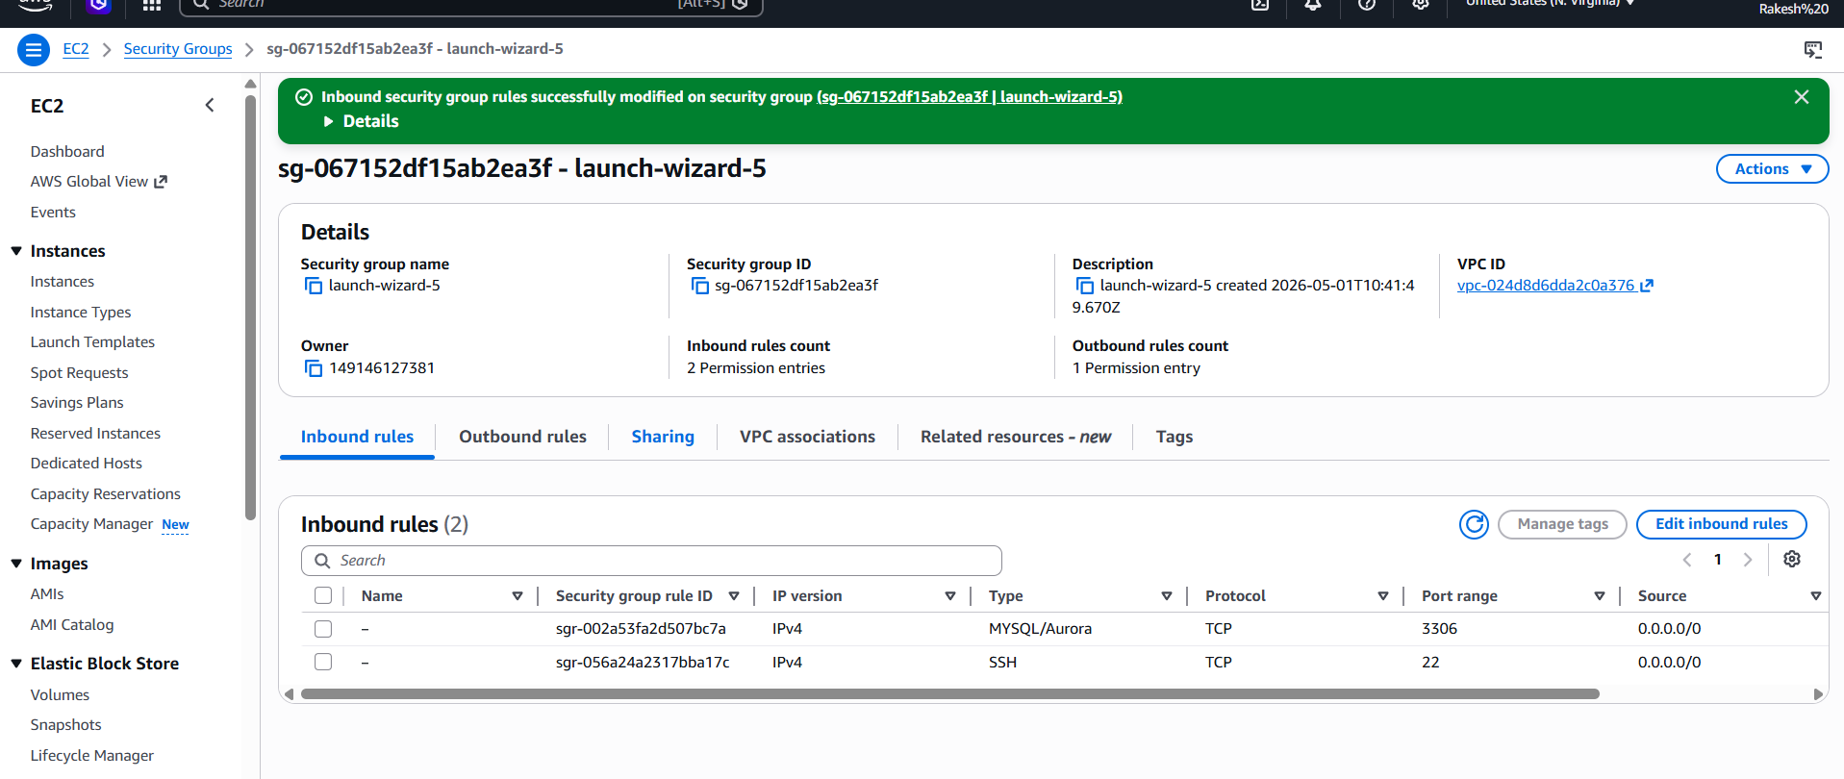
- Insert some dummy data.
- Login to MariaDB
- Select Your Database
- Create a Table
- Insert Dummy Data
- Verify Data

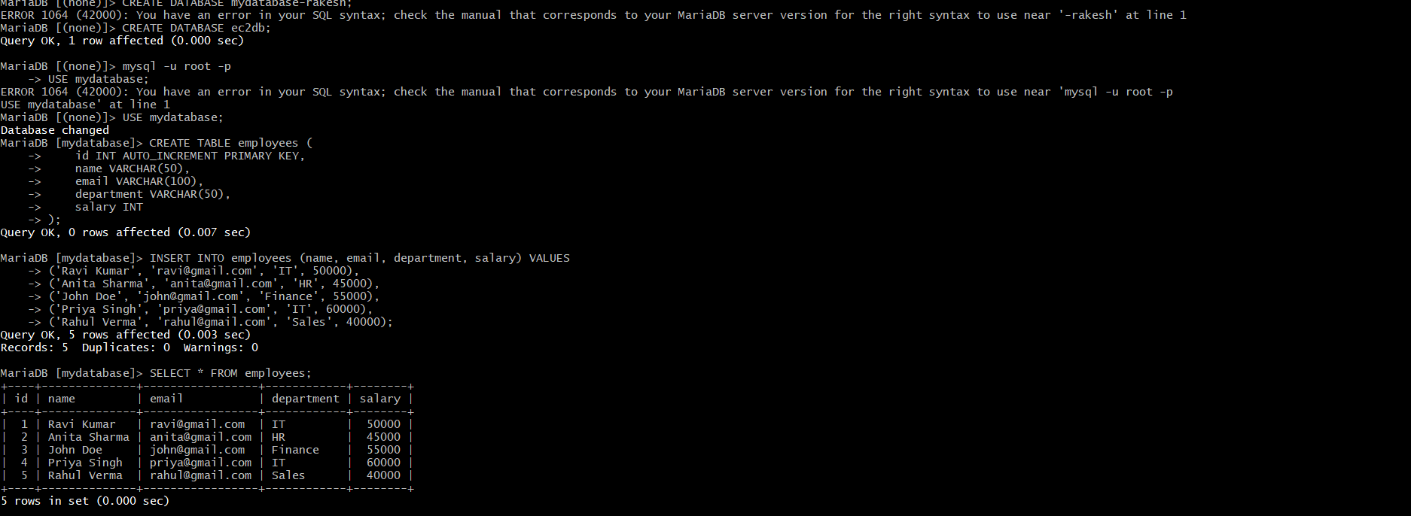
- Take the backup of dummy data on EC2.
- Connect to Your EC2 Instance
- Take Backup Using mysqldump Take Backup Using mysqldump
- Verify Backup File
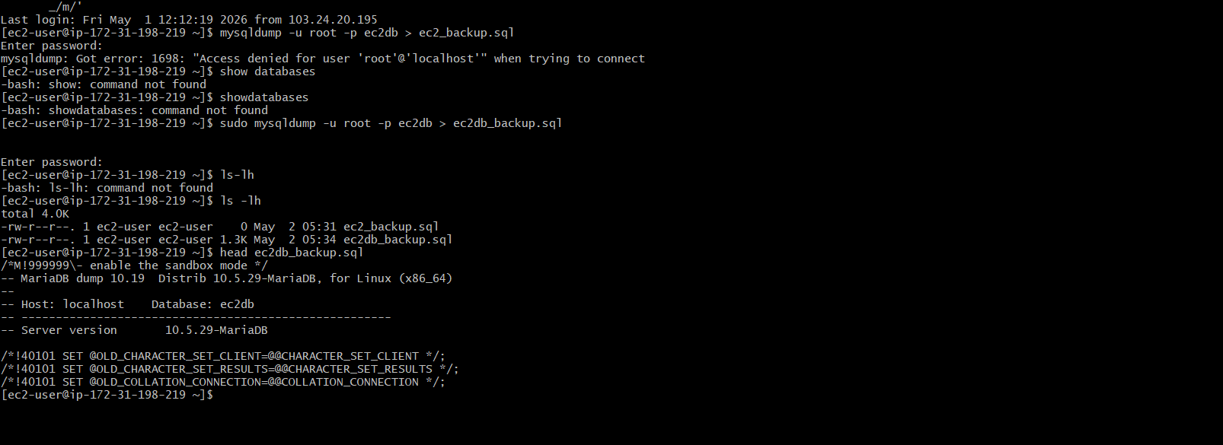

- Launch MariaDB RDS instance.

Created a new database in rds and then provided required details as shown in below image
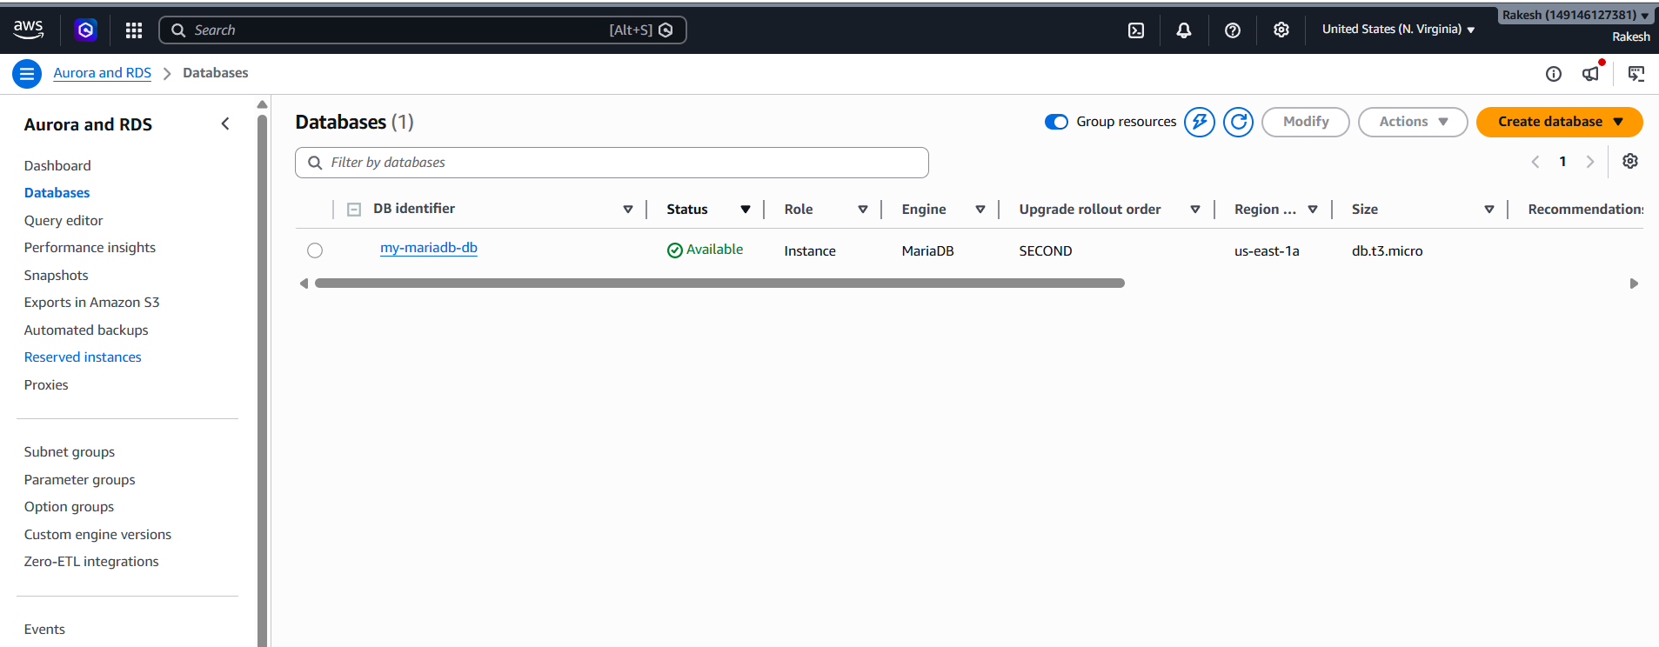

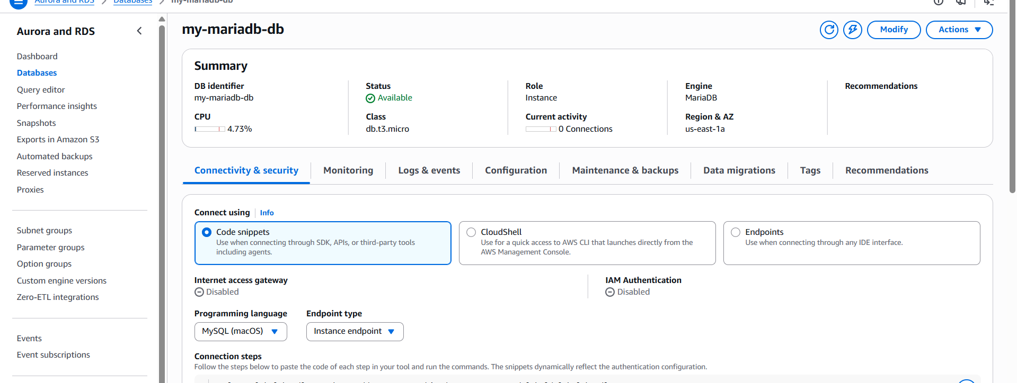
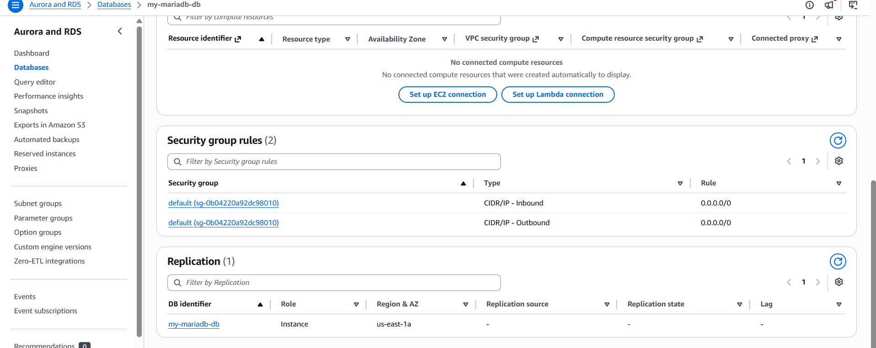

- Migrate database from EC2 to RDS.
Connected to maria db via start point link and end point link
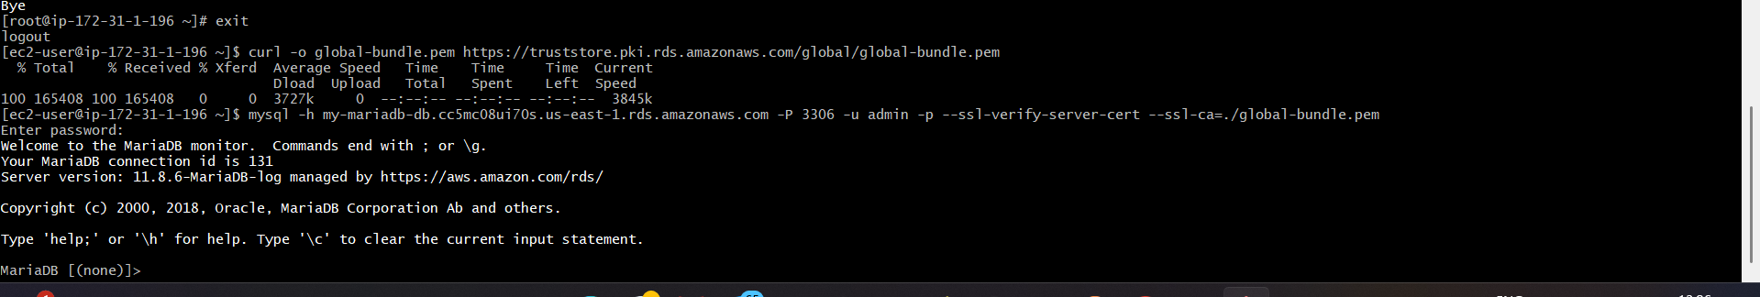
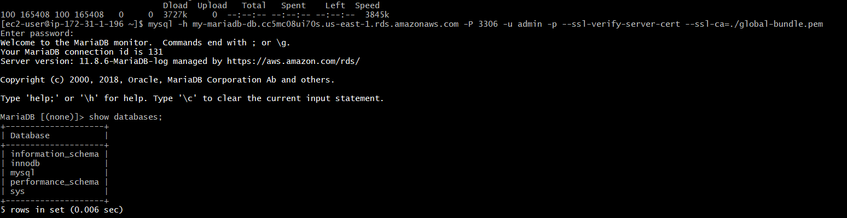

- Install MySQL DB on EC2.
Download mysql
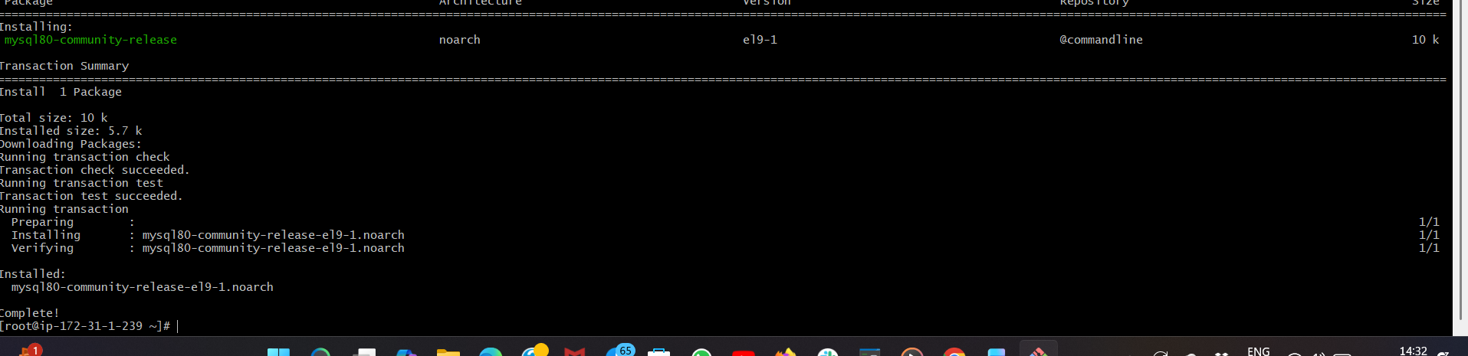
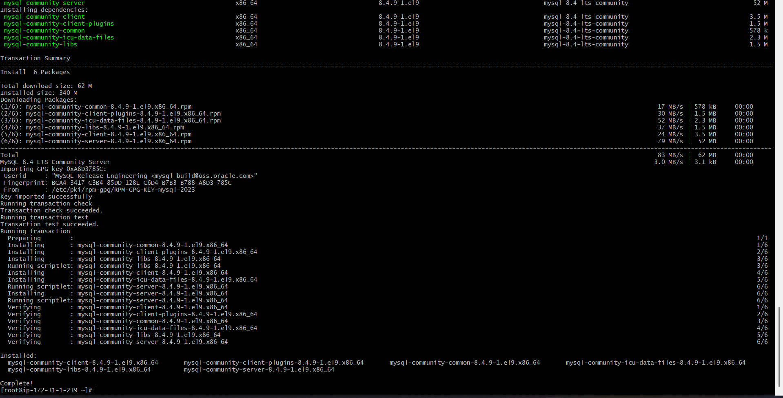
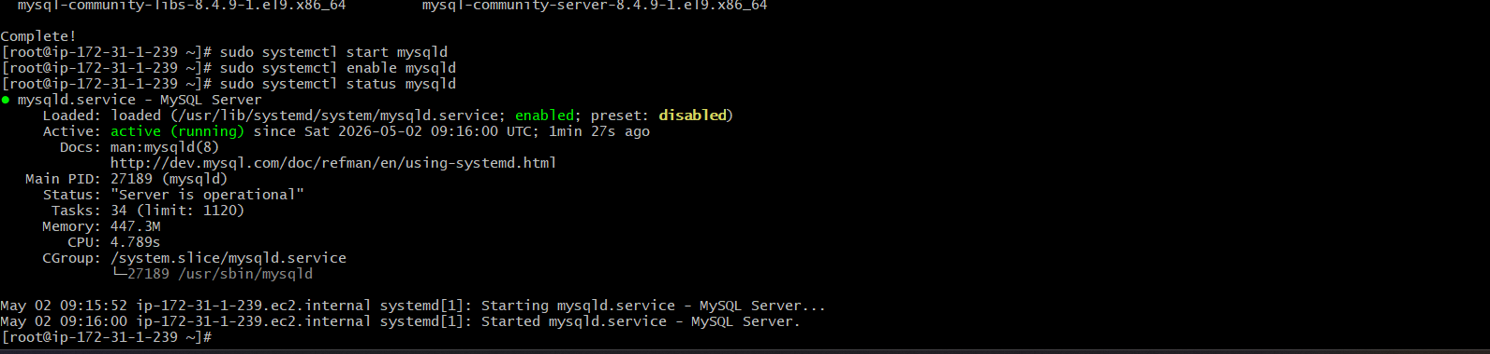

- Launch MySQL RDS image.
Created a new database with the required details as shown in the below
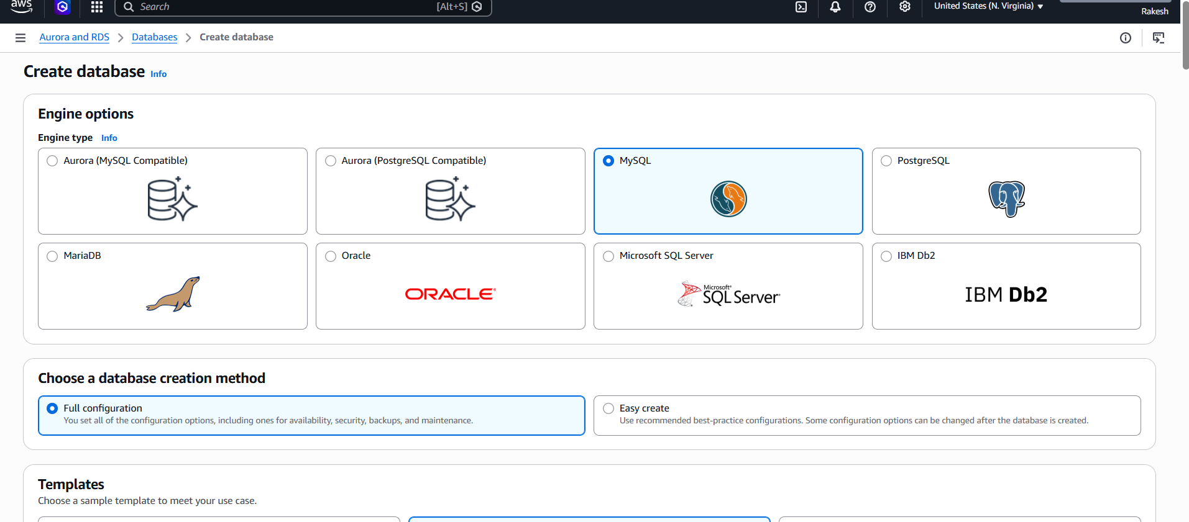
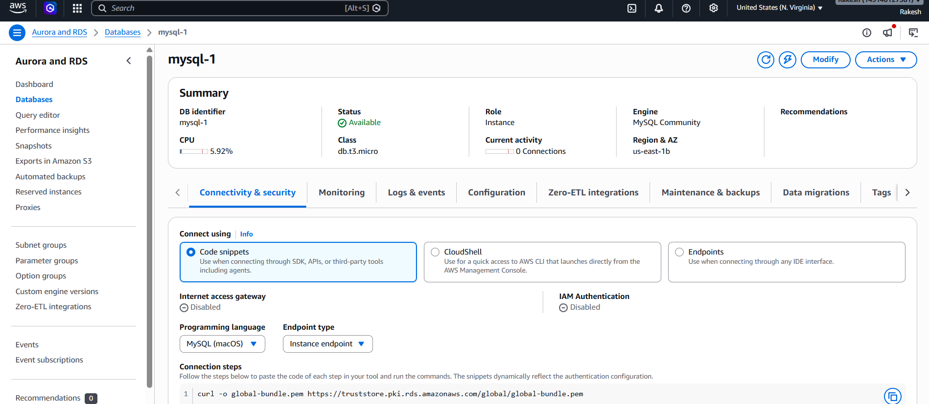

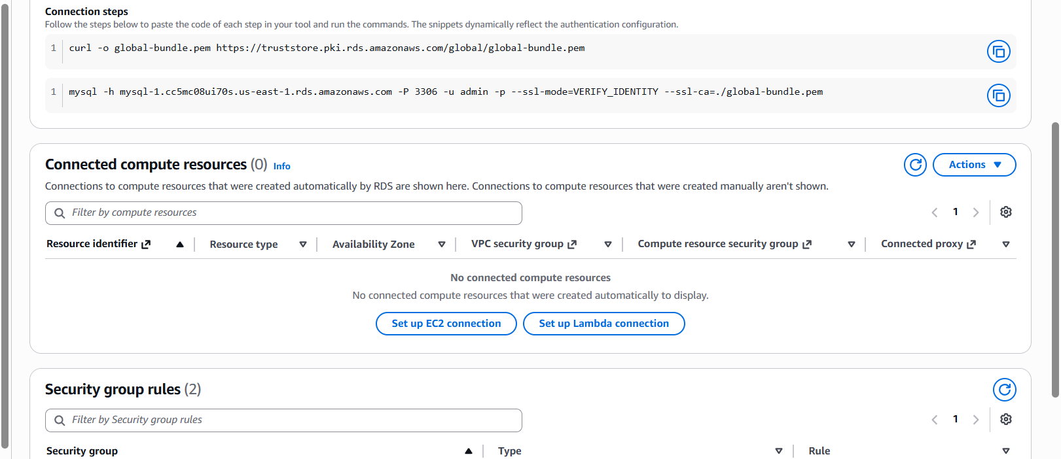

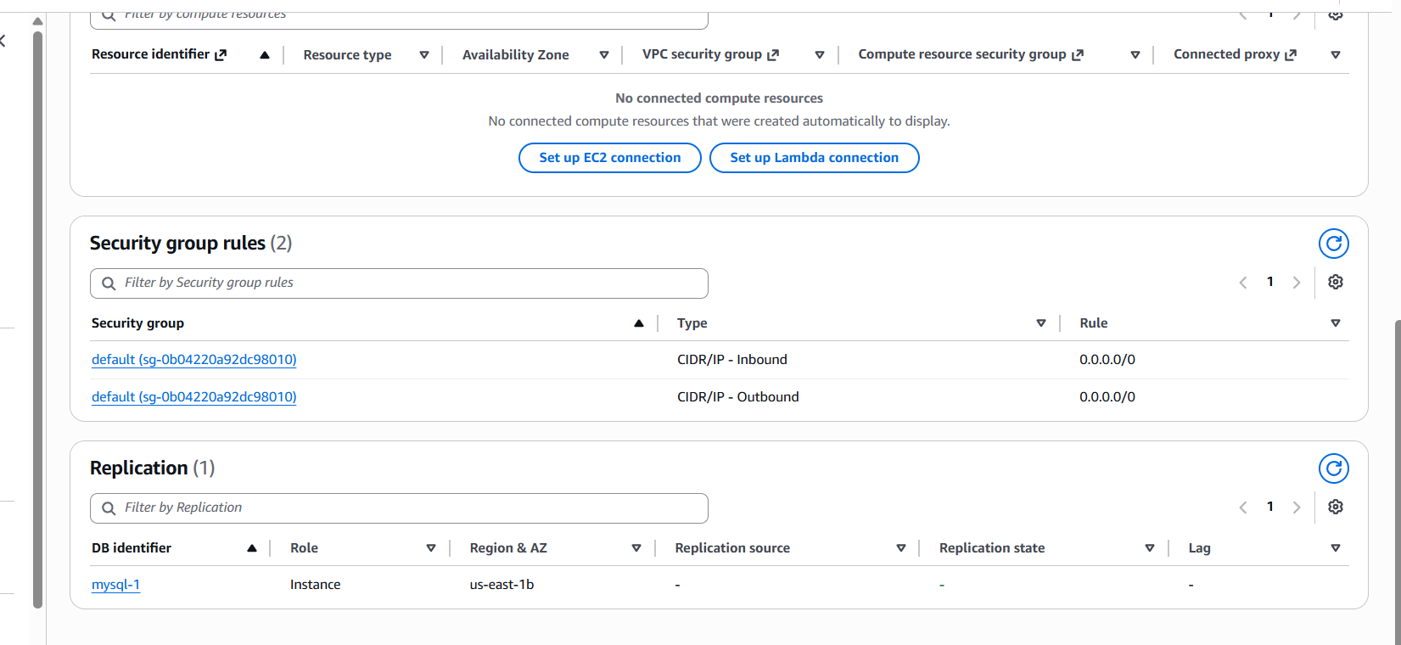

- Configure Multi-AZ.
Unable to process the task because of the free-tire account, it can only be
done in via paid account.
- Take backup of DB and restore the DB.
Go to database -- click on action -- click on snapshot -- assign snapshot name
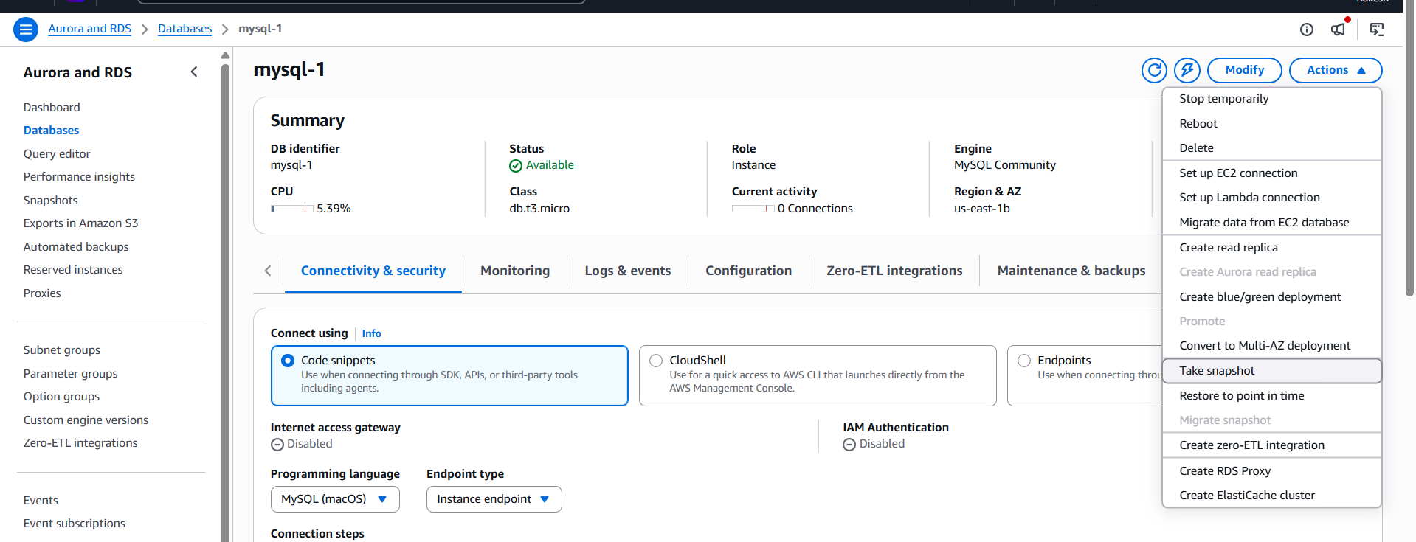

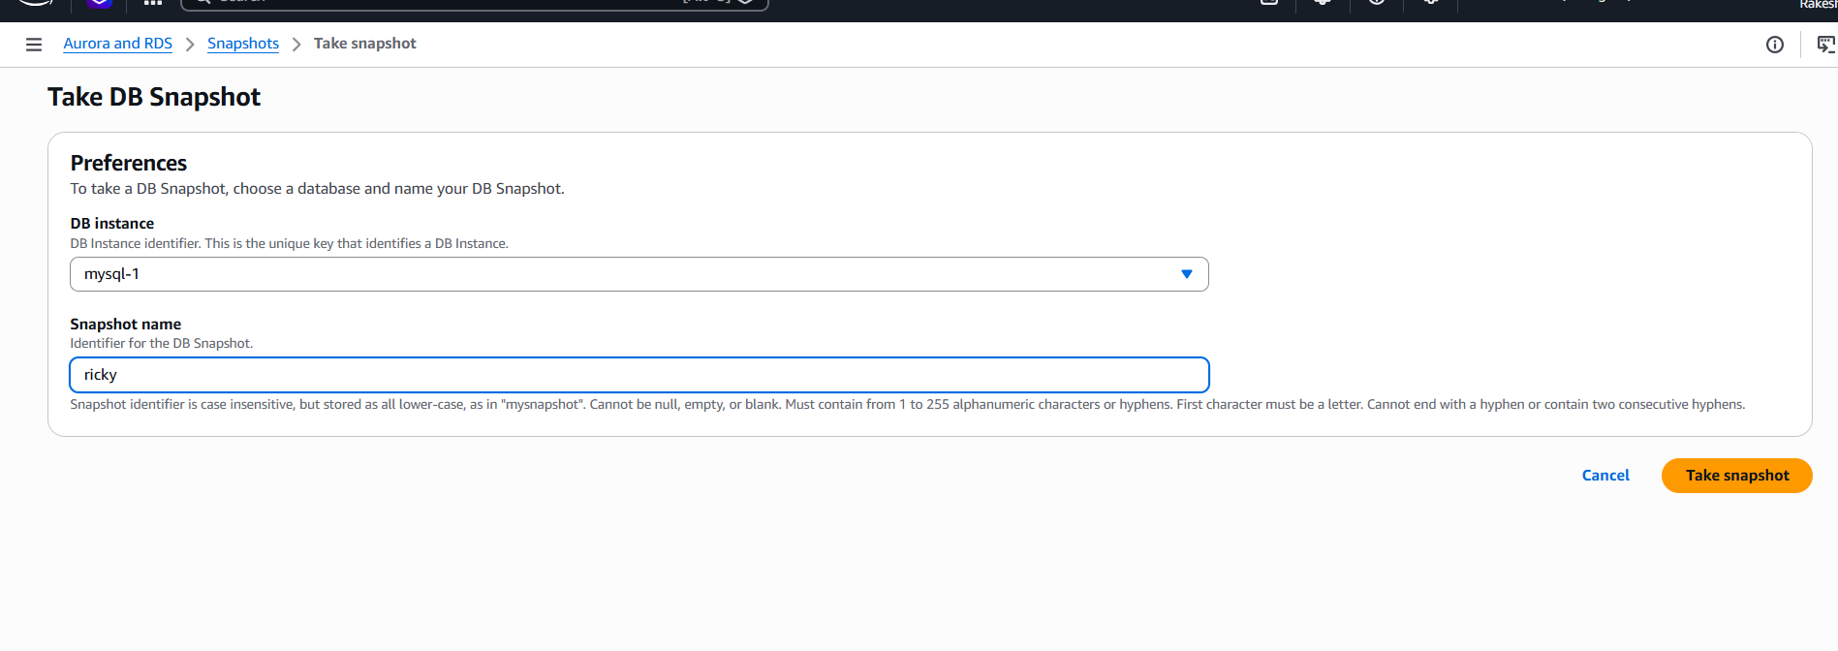

Snapshot is created
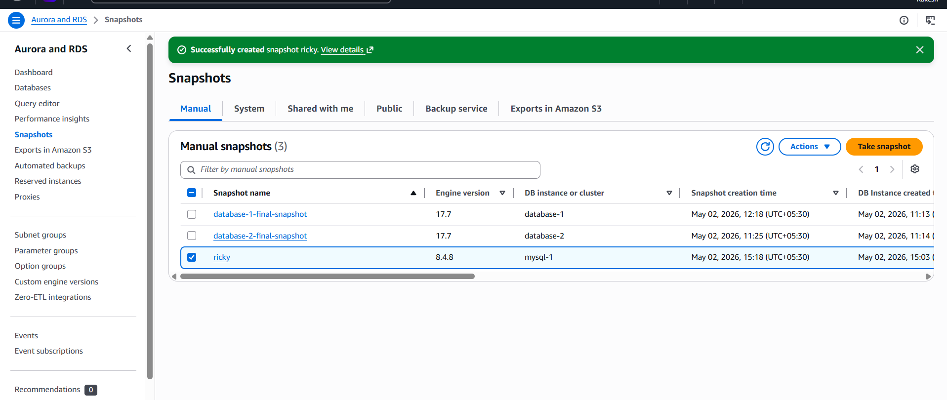

Sucessfully deleted the 2nd database after creating a snapshot and then
will try to restore it with the help of snapshot:
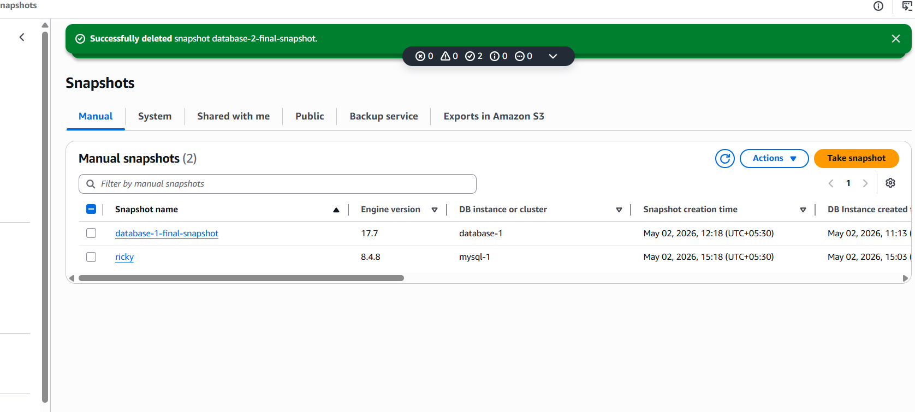
To restore the snapshot click on actions
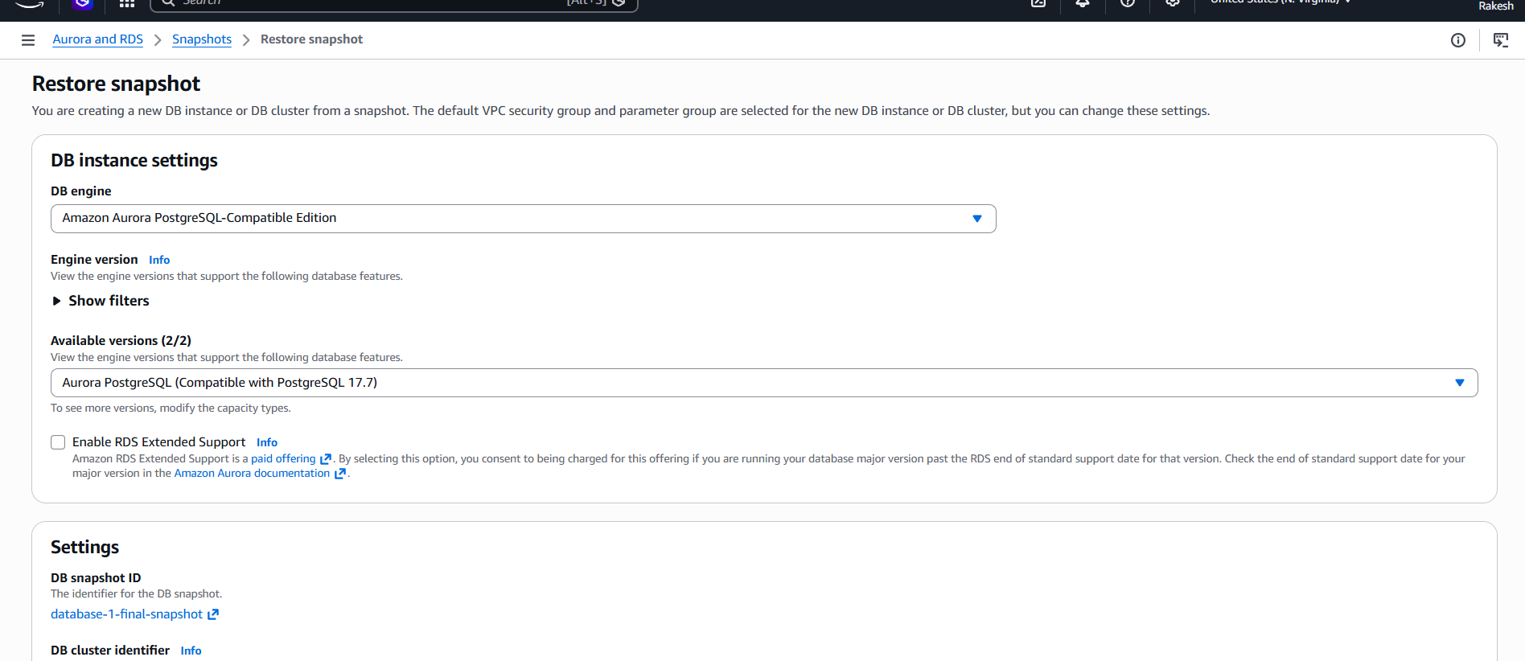

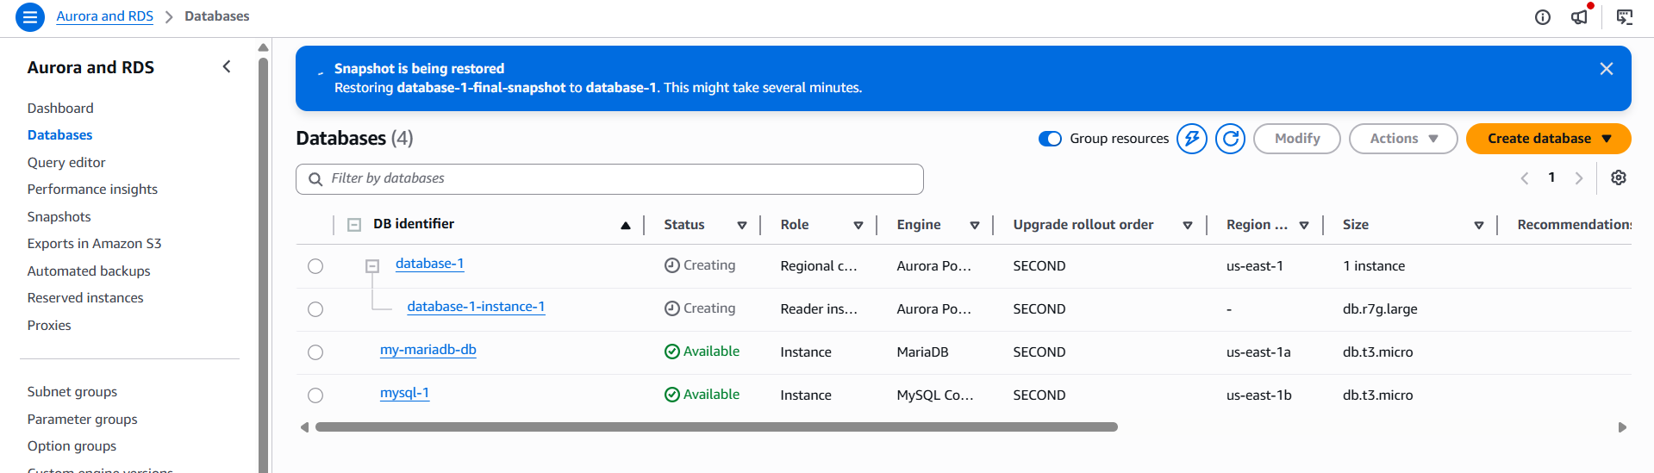
Checked with the ec2 instance as well with the end point if the database
is restored or not:
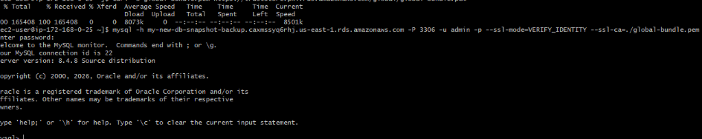

- create read replica.

Successfully provided the details for read replica but was unable to
complete as the error message shows limited access to free account,
need to upgrade to paid account
Followed the below settings as shown in the image:
